Executive Summary

SolStar
Illuminating Solar Power

Josh Bram, Molly Eckman, Alex Gordon
PI: Khanjan Mehta, Director, HESE Program

Humanitarian Engineering and Social Entrepreneurship (HESE) Program
The Pennsylvania State University

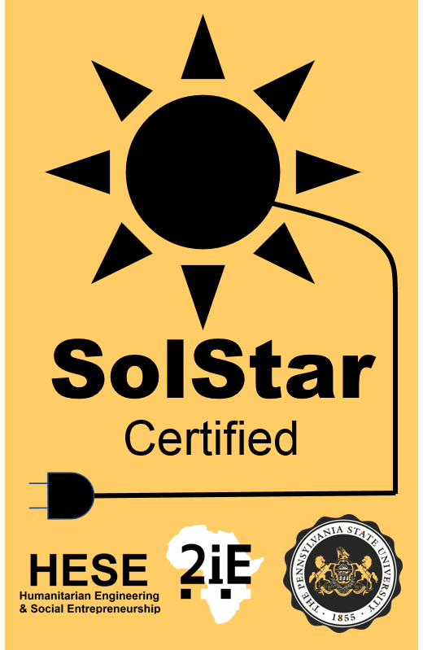

Website: solstar.weebly.com
<Three>-minute Video Pitch:

Currently, only 15% of the population in Burkina Faso has access to electricity [CITE]. While solar power offers a promising alternative to the expansion of grid power, sales in this region suffer due to lack of awareness and market spoilage [CITE]. This situation means that if a small businessman would like to purchase solar panels in order to power lights to keep his shop open longer, he may end up purchasing a poor quality panel. He may then lose trust in solar panels in general and refuse to purchase again.

In order to combat this market spoilage, SolStar provides manufacturers a new certification designed specifically for Burkina Faso that will increase consumer trust in their products. Solar panels can receive SolStar certification after passing a series of stringent tests, including a visual inspection, a power output evaluation, a long-term degradation test, and physical durability test. The exact nature of these tests is currently under development as part of a partnership with the International Institute for Water and Environmental Engineering (2iE) in Ouagadougou, Burkina Faso.

While other certification systems for solar panels exist, none so far have established a presence in Burkina Faso. The nonprofit organization Lighting Global, which certifies solar lanterns in other countries across Africa, is SolStar’s closest competitor. However, Lighting Global is always searching for valuable third-party partnerships, and instead of competitors, they may prove to be a useful partner moving forward.

SolStar’s primary customers are solar panel manufacturers that export (or plan to export) products to West Africa. These manufacturers, recruited by the SolStar CEO, will pay to have their panels tested and certified. Testing will be conducted by trained technicians at 2iE. In addition, to combat the lack of awareness of the utility of solar power, outreach agents will be hired to conduct training sessions with solar power retailers on the best methods of panel sale. Additional funding will be sought from relevant nonprofits and aid organizations. Expansion of the business will be accomplished through the acquisition of additional manufacturers by the CEO.

This venture relies on a strong partnership with 2iE, as their labs will be the site of solar panel testing, and technicians will be hired from 2iE graduate programs. 2iE will benefit from brand enhancement. The first steps of implementation include pitching the venture to 2iE faculty or administrators, hiring the CEO and technicians, and acquiring the first manufacturer. Sales of manufacturers who have attained certification will be closely tracked to ensure that SolStar certification predictably increases solar panel sales.

Contact Information
Molly Eckman, BS, Biomedical Engineering, mce5066@psu.edu
Prof. Khanjan Mehta, Director, HESE Program, khanjan@engr.psu.edu

